**Star Trek Voyager**

**Submitted by**

**Rashika Mishra**

**Summary**

The goal of this project was to design a 2 Dimensional game based on Physics. The main working principle of this game is Gravity and how it effects physical bodies.

We have developed a game prototype with five set levels where the player is able to guide a character (ship) in space by warping from one revolving planet to another through navigating each planet’s gravitational pull.

**The Game**

The game prototype is developed using Unity game engine and C#. The game has following features:

1. Displays space map with different textured planets.

Each level has its own space map and the planets are arranged randomly. Every planets is displayed using a texture bitmap and base color with its own light. The final planet to change the level has a base color of green.

1. Displays an active gravitational field around each planet.

Each planet has a halo effect on it to display the gravitational field around it. Every planet has an active gravitational field which is proportional to the mass of the planet.

1. Displays a playable character on first planet and character action through mouse character.

At the start of each level the game displays a ship character on the first planet which can navigate across the space map through mouse clicks.

1. The game has a score system dependent on the number of planets visited on each level.

Every planet visited for the first time adds one point to the total score but to finalize the score for a level, the level needs to be cleared by reaching the green planet.

**The Logic**

1. The game starts with the character landed on the first planet and under its gravitational pull rotating with the planet.

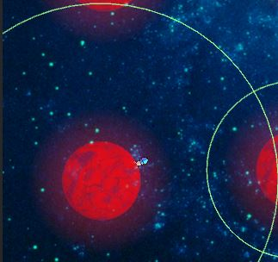

1. 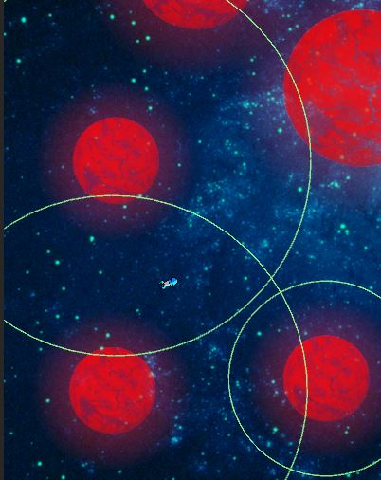The game is a gravity based simulation game and hence every planet has an influence on the ship if it is close enough to the planet.

In above picture the ship is influenced by the gravitational pull of the leftmost two planets. (The gravity range is shown with green circle).

The gravitation pull is decided by the physics formula:

1. All the gravitation fields are calculated and the resultant is applied to the Ship character to decide the direction vector of translation and the distance of translation.



1. When we launch the ship character from a planet it escapes in the up direction of planets rotation with a speed to reach escape velocity is calculated proportional to the mass of the planet and time.

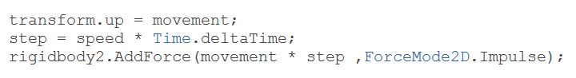

1. The ship lands on the next planet by detecting a collision between the planet’s surface and the ship’s surface. The game is using Unity’s colliders to define the collision surfaces and event handling to land on a planet after collision.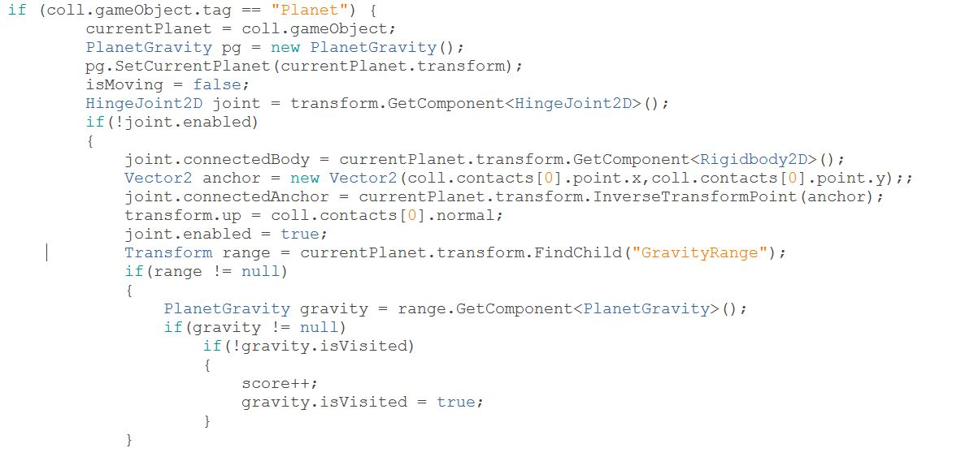

**Game Output**

1. Welcome Screen

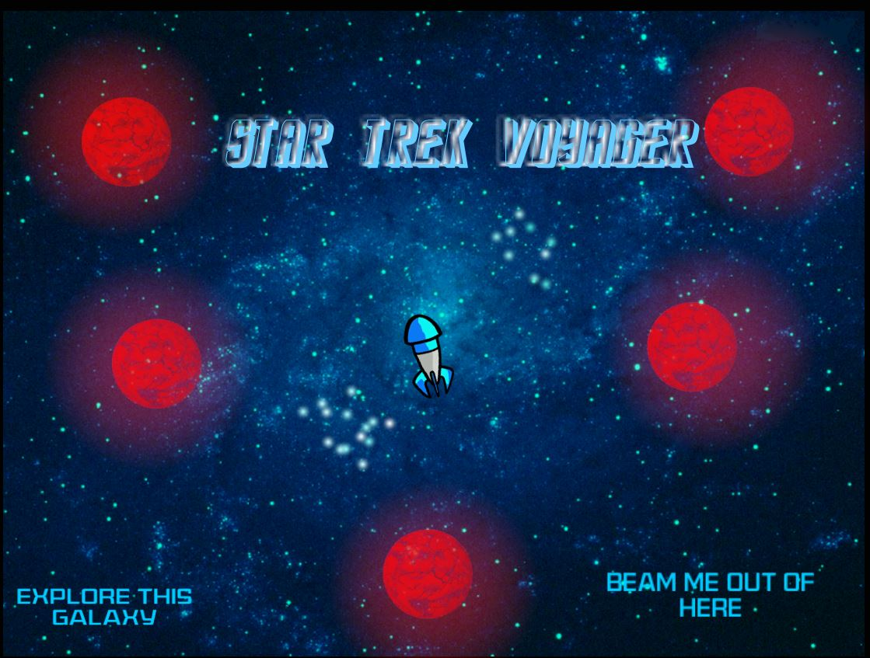

1. Level 1

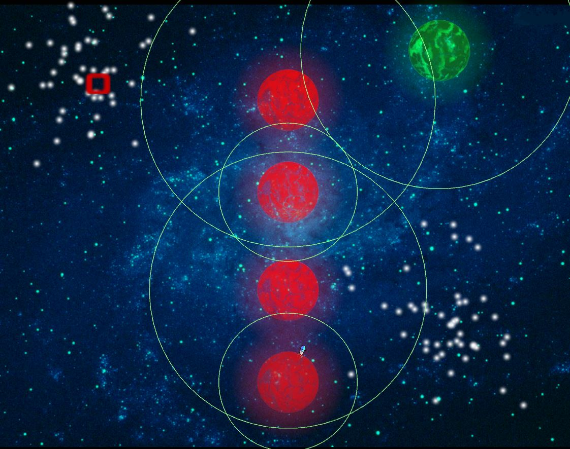

1. Level 2

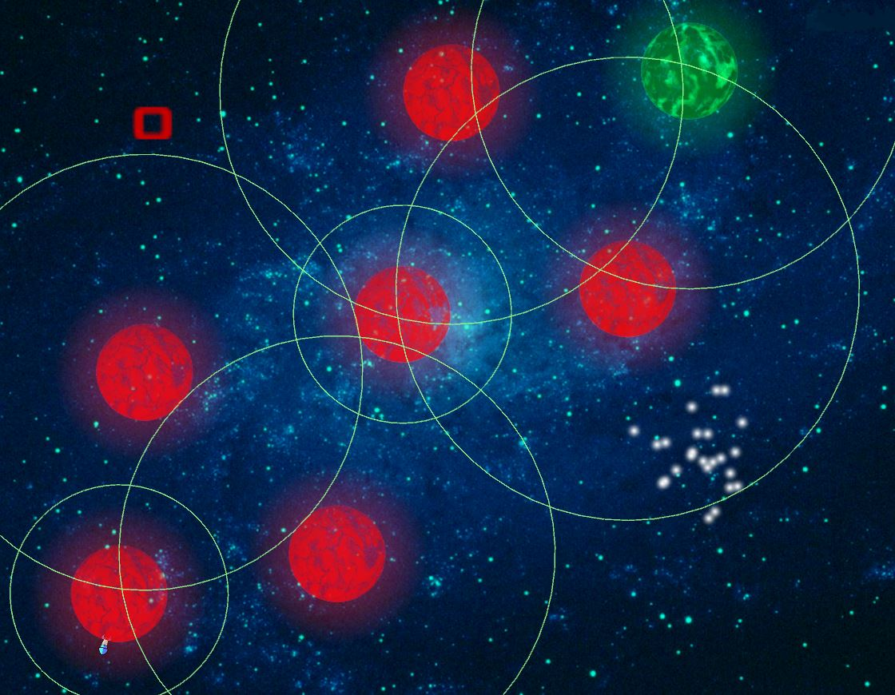

1. Level 3

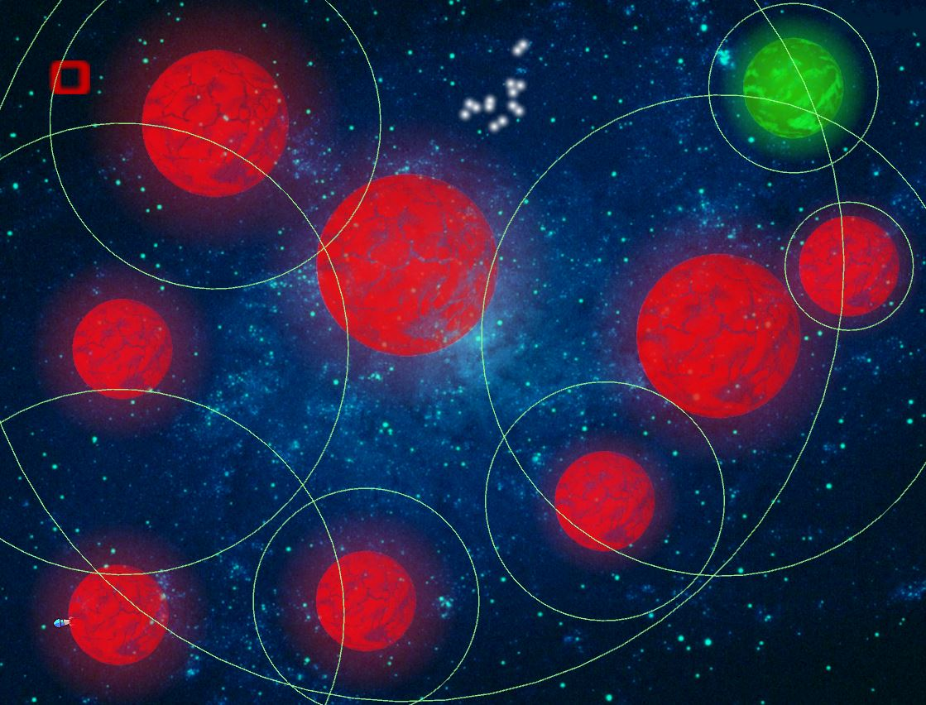

1. Super Level

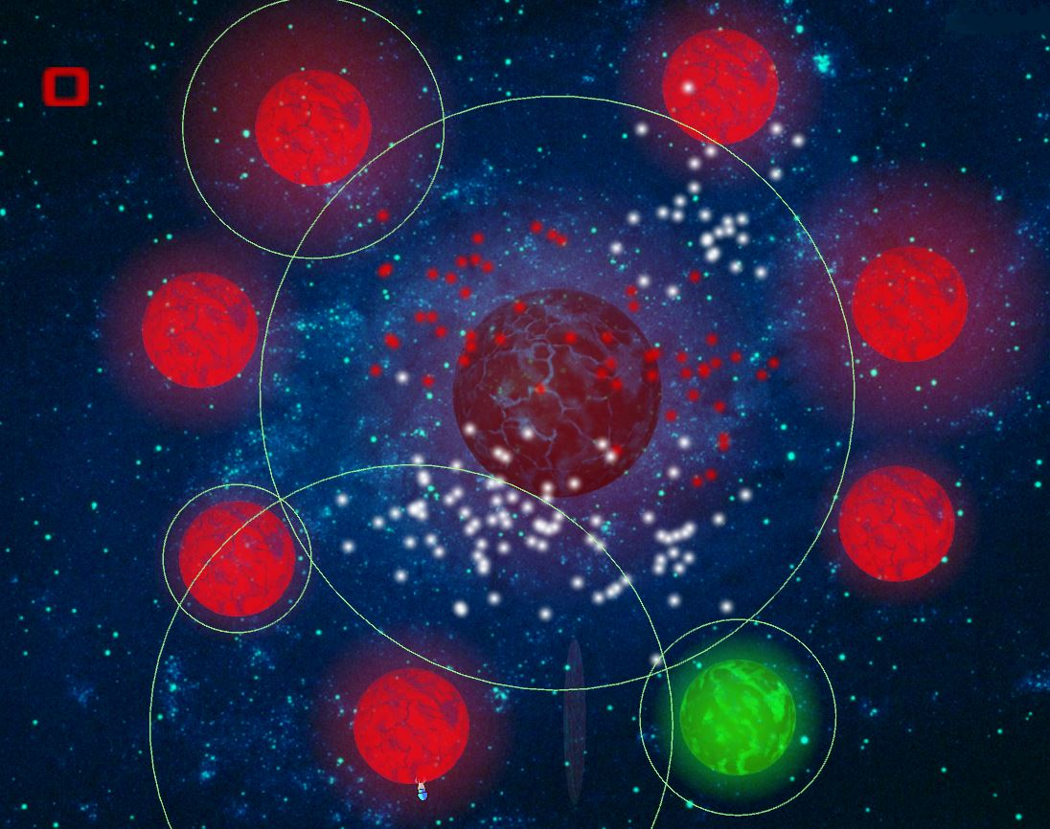

1. Menu Page

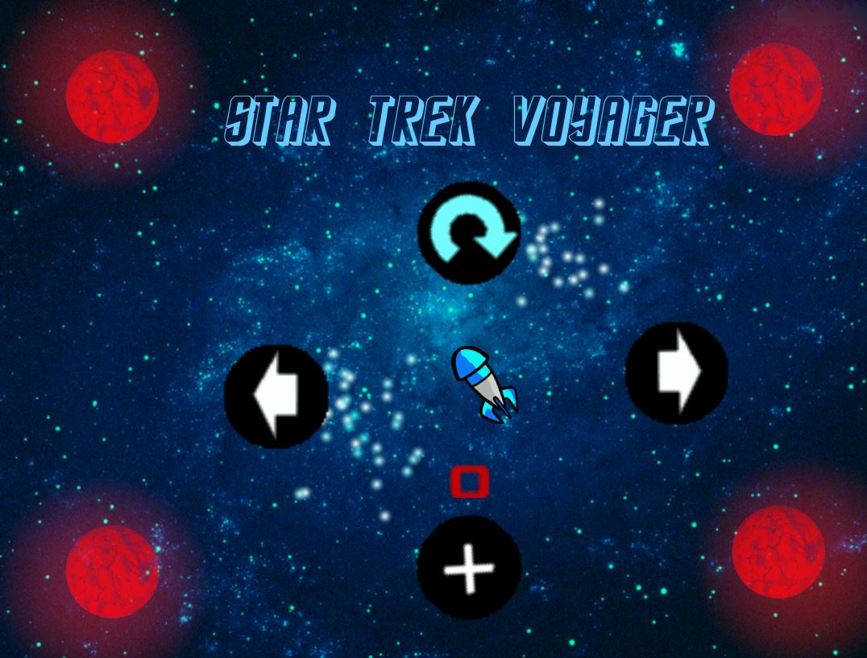

**Conclusion**

The aim of the project to develop a fun game based on gravity with defined graphics was achieved in this prototype.

We got the opportunity learn a new game engine and its features like the use of Scenes, Prefabs, Physics engine, Joints, Collisions, Animations et al.

The designed game is a prototype on a very small level and was implemented as a learning procedure and also to see the viability of the idea if developed as a full featured game.

The full game can have features like,

1. Warping through black holes
2. Different textured planets
3. Obstacles such as asteroids hitting the character et al
4. Random position of planet changing with each level.

An example of a full game can be seen in a soon to be released game Planet Hopper on www.planethoppergame.com.